AITSE 0512

NATIONAL TEACHERS COUNCIL
ALL INDIA TALENT SEARCH EXAMINATION: 2012

CLASS V

Duration: 90 Minutes Maximum Marks: 90
General Instructions to Candidates
1. This question paper contains 90 multiple choice questions each of one mark.
2 The question paper is divided into two sections, A and B
3. Section A is Scholastic Aptitude Test (SAT), contains 50 questions. This section covers Environmental Science and Mathematics.
4. Section B is Mental Ability Test (MAT), Computer Awareness and General Knowledge, contains 40 questions.
5. There will be no negative marks for wrong answer.
6. A separate answer sheet is provided for answering the questions. Each question should be answered by darkening the appropriate circle (A, B, C, or D) with a blue or black ball pen.
7. Answer recorded once in the answer sheet cannot be altered.
8. All rough works should be done only in the space provided for rough work in this question paper.
9. Calculator is not permitted in the examination hall.
10. Candidate should write his / her name in the space provided for the purpose.

Name

SECTION A

1. Which of the body parts are called “Gate ways” of knowledge?
A) Nervous System B) Sense organs C) Legs D) Hands
2. Farmers use different methods to maintain the quality and improve the fertility of the soil. Some farmers grow different crops in different seasons in the same field. This method of cropping is known as
A) Seasonal cropping B) Multiple cropping
C) Crop rotation. D) Mixed cropping
3. The life process that ensures the continuity of a species on the planet earth
A) Reproduction B) Photosynthesis C) Digestion D) Respiration
4. Coal, Natural gas and petroleum are called fossil fuels. The excessive use of fossil fuels leads to global warming. A gas produced on burning fossil fuels and cause global warming
A) Carbon monoxide B) Sulphur Dioxide C) Oxygen D) Carbon dioxide
5. Identify the correct statement:-
A) The bright coloured part of flower is called sepals
B) The flowers that bloom in night are generally yellow in colour
C) Night blooming flowers have good fragrance
D) Both (B) & (C)
6. The ancient India produced many great mathematicians, astronomers and doctors. Who among these were two ancient astronomers?
A) Aryabhatta & Bhaskaracharya B) Aryabhatta & Susrutha
C) Banabhatta & Susrutha D) Bhaskaracharya & Varahamihira
7. Who developed polio vaccine?
A) Alexander Fleming B) Jonas Salk
C) Edward Jenner D) Louis Pasteur
8. In the early morning we can see droplets of water on the leaves of grass and plants. These water droplets are called
A) Fog B) Rain C) Mist D) Dew
9. The process of changing ice into water is called melting. The change of water into ice is known as
A) Evaporation B) Condensation C) Freezing D) Fusion
10. Which one of the following statement is NOT correct?
A) Both potable and distilled water are safe for drinking
B) Potable water is safe for drinking, but distilled water not
C) Potable water contains small amount of minerals
D) Both (B) & (C)
11. The “Venus fly trap” closes its lid when the housefly enters it. What stimulus causes this response?
A) Water B) Touch C) Light D) Gravity
12. A person met with an accident and wrapped himself in a blanket. The accident may be due to
A) cut B) Poisoning C) An electric shock D) Burns
13. A stone thrown up into the air, it will come down after some times. This is because of
A) Frictional force B) Magnetic force C) Gravitational force D) Electrical force
14. An inclined plane is an example of
A) A complex machine B) A simple machine
C) An easy machine D) A compound machine
15. Identify the plant from the below given informations:-
- Leaves are modified into spines
- Stem is thick & fleshy
- Stem carries out photosynthesis
A) Cactus B) Banana
C) Rose D) Lily
16. Our body has 206 bones connected by movable or immovable joints. The type of joint in our shoulder
A) Shoulder joint B) Hinge joint C) Ball & socket joint D) Pivot joint
17. Length: Metre:: Temperature: ……………….
A) Heat B) Cold C) Degree D) Degree Celsius
18. Green plants are the first link in the food chain. This is because they
A) Are more in number B) Are eaten by all the animals
C) Can prepare their own food. D) Can’t move from one place to another

19. The smallest planet of the solar system
A) Mercury B) Venus C) Pluto D) Jupiter
20. Which one of the natural phenomena brings molten rocks to surface of the earth from its interior?
A) Earthquake B) Tsunami C) Tidal waves D) Volcano
21. Which of the following is NOT a cause for change of seasons?
A) The slanting of the Earth’s axis B) The shape of the Earth’s orbit around the Sun
C) The Earth’s revolution around the Sun. D) The Earth’s spinning on its axis.
22. The inventor of Telephone
A) Alfred Nobel B) Graham Bell C) Thomas Edison D) Isaac Newton
23. Which one of the following expands more on heating?
A) Steel B) Water C) Milk D) Oxygen
24. Read the following statements carefully and mark the correct option:
P Kerosene floats in water
Q Kerosene is denser than water.
A) Both the statements P and Q are true B) Both the statements P and Q are false
C) Statement P is true and Q is false D) Statement P is false and Q is true
25. Which is the longest latitude?
A) Equator B) Arctic Circle C) Tropic of Cancer D) Tropic of Capricorn
26. The LCM of 3, 5 and 6 is
A) 6 B) 15 C) 30 D) 60
27. Time quarter past 12 night is
A) 1215 hrs. B) 2345 hrs. C) 1145 hrs. D) 0015rhs.
28. Two lines intersect each other and make an angle of 90⁰ between them. The lines are called
A) Coplanar lines B) Perpendicular lines C) Parallel lines D) Collinear line
29. How many $\frac{1}{4}$ make 3
A) 4 B) 8 C) 12 D) 3
30. The sum of 17$\frac{1}{4}$ and 18 $\frac{3}{4}$ is
A) 36 B) 35 C) 36$\frac{1}{4}$ D) 35$\frac{3}{4}$
31. Which of the following is a true statement?
A) Parallel lines always intersect B) Perpendicular lines never intersect
C) Intersecting lines are never parallel D) Intersecting lines are always perpendicular
32. The numeral for the expanded form 50000 + 3000 + 10 + 3
A) 53313 B) 50303 C) 50313 D) 53013
33. Mr. and Mrs. Bablu have three daughters. Each of them has two brothers. How many children does Babul’s family have?
A) 5 B) 7 C) 9 D) 10
34. If 3 x 2006 =2005 +2007 +X, then X is equal to
A) 2007 B) 2006 C) 2005 D) 2004
35. The value of the expression 4 x (9 – 6) is
A) 60 B) 30 C) 15 D) 12
36. Which of the following is arranged in the order greatest to lowest?
A) 0.34, 0.29, 0.4, 0.04 B) 0.04, 0.4, 0.29, 0.34
C) 0.4, 0.34, 0.29, 0.04 D) 0.29, 0.34, 0.04, 0.4
37. The reciprocal of $\frac{7}{5}$ is
A) $\frac{5}{7}$ B) $1\frac{2}{5}$ C)$5\frac{2}{3}$ D) $\frac{12}{5}$
38. P and q are respectively 20% and 10% lower than C. What percentage of Q is P?
A) 45 B) 50 C) 66.66 D) 88.88
39. The place value of 5 in 157278 is
A) Million B) Fifty thousand C) Hundred million D) Ten thousand

40. Place value and face value of a number is always equal at
A) Hundred’s Place. B) Ten’s Place C) One’s Place D) None of these
41. What number am I?
- I am a two digit number, I am a common multiple of 6 and 7 and I have a total of 8 factors.
A) 84 B) 56 C) 36 D) 42
42. Find the mixed number represented by two shaded figure given below:

A) 1$\frac{2}{3 }$ B) 1$\frac{2}{3 }$ C) 2$\frac{2}{3 }$ D) 2$\frac{1}{4 }$
43. What is 13.73 rounded to the nearest tenth?
A) 13.0 B) 13.8 C) 13.7 D) 14.0
44. What fraction of the figure is shaded?
A) $\frac{1}{3 }$ B) $\frac{2}{6 }$
C) $\frac{6}{18}$ D) All of these
45. If radius of a circle is 5 cm, its diameter is
A) 6 cm B) 10 cm C) 2.5 cm D) 5.5 cm
46. A rectangular field that is 100 m by 120 m. What is the perimeter of the field?
A) 440 m B) 12000 m² C) 220 m D) 1200 m²
47. The product of 8 and smallest 3-digit number formed by 4, 2 and 5 is
A) 800 B) 3400 C) 2032 D) 1960

48. If represents $\frac{2}{3 }$ and represents $\frac{2}{3 }$ then,
+ is equal to
A) $\frac{16}{8 }$ B) $\frac{8}{4}$ C) 2 D) All of these
49. 120m is equal to
A) 12km B) 1.2Km C) 0.12Km D) 0.012Km
50. What number can replace “?” in $\frac{0.0027}{?}$ = 0.27
A) 0.1 B) 0.01 C) 0.001 D) 27
SECTION B

51. The adjacent picture shows:
A) Computer hardware
B) Computer software
C) System software
D) Computer applications

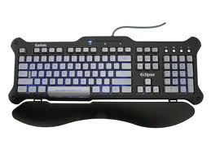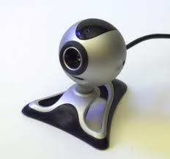
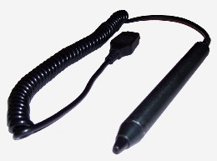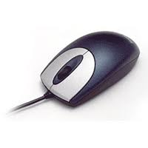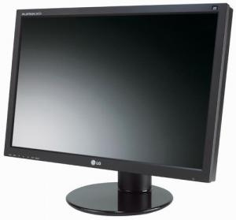

52. A fast economical and convenient way to send messages to another computer using a modem is called
A) Internet B) E – mail C) Messaging D) Chatting
53. Where can you find command to save your document?
A) File B) Edit C) Format D) Tools
54. Nandan wants to write heading for a poem. Which one of the following button would help him to align the text in the centre?
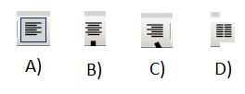

55. The following window helps you to:
A) Edit and type Word Art
B) Edit text
C) Type Address
D) None of these
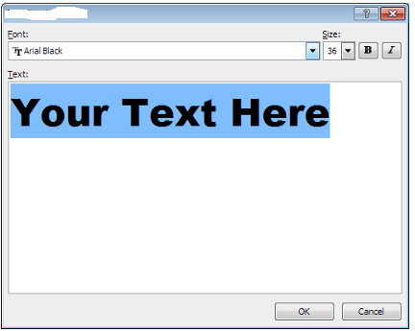
56. Who was the first European traveler to reach India via Africa by sea?
A) Thomas Roe B) Muhammad Ghor
C) Vasco Da Gama D) Ibn Batuta
57. Who was India’s second Prime Minister?
A) Jawaharlal Nehru B) Gulzari Lal Nanda
C) Indira Gandhi D) Charan Singh
58. What is the importance of ‘Amundsen Ronald’?
A) Discovered America B) Discovered South Pole
C) Discovered Hudson Bay D) Discovered North Pole
59. Which one of the following state is known as ‘Land of rising Sun’?
A) Norway B) Finland
C) Laos D) Japan
60. Ayodhya is situated in the bank of which one of the following river?
A) Alkananda B)Sarayu C) Satluj D) Musi
61. There are four Vedas- Rig Veda, Yajur Veda, Sama Veda, Adhrva Veda. Which is the oldest of them all?
A) Rig Veda B) Yajur Veda C) Sama Veda D) Adhrva Veda
62. Who was the author of ‘Panchtantra’?
A) Banabhatta B) Kalidasa
C) Vishnu Sharma D) Taya Zinkin

63. This nuclear power station was in news for last many days due to the protest of local people. In which state of India it is situated?
A) Karnataka B) Gujarat
C) Maharashtra D) Tamil Nadu
64. Identify the flag.
A) National flag of Canada
B) Flag of international Olympic Association
C) Flag of United Nations Organization
D) Flag of Common wealth Nations
65. Which one of the following is the longest National High way in India?
A) NH 2 B) NH 3 C) NH 6 D) NH 7
66. Identify this historical Incident.
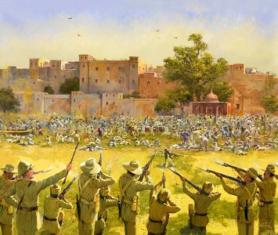
A) Quit India Movement
B) Jallianwalla Bagh Tragedy
C) Non co operation Movement
D) Salt Satyagraha
67. ‘Dronacharya’ awards are given to:
A) Athlets B) Spoarts coaches
C) Musicians D) Journalists
68. According to 2011 census population growth rate in Kerala is the lowest among all major Indian states. Which of the following is the widely accepted reason?
A) This State has highest literacy rate.
B) This state invested more money in population control
C) This sate invested more money in health and education fields
D) None of these
69. Konkan railway constructed in which part of India?
A) East B) West C) North D) North East

70. Who wrote ‘Gulliver’s Travel’ a book famous all over the world.
A) J K Rowling B) C. S Lewis
C) Jane Austin D) Jonathan Swift
71. Replace the question mark.
A) T
B) U
C) 20
D) 21
7
?
R
15
K
16
L
8
D
S

M
9
E
2
17
10
F
3
A
N

72. Replace the question mark.
2097152
32
?
256
8
4
2

A) 8192 B) 10987 C) 512 D) 750
Direction for question No 73 to 75:- Find the odd one out
73.
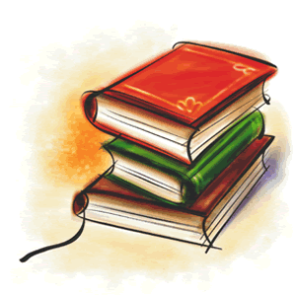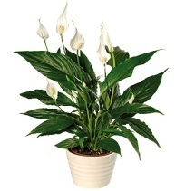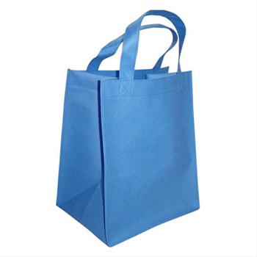
A) B) C) D)
74.
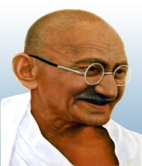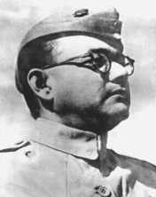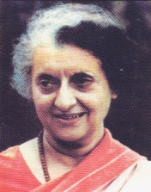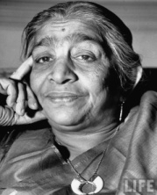
A) B) C) D)

75.
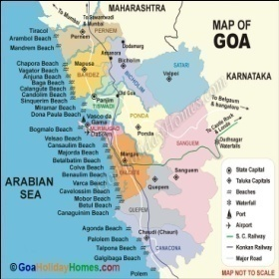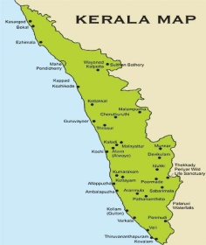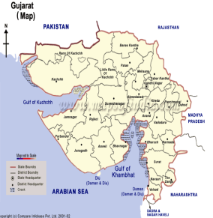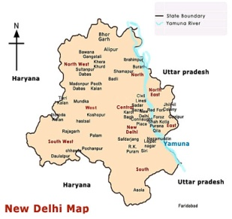
A) B) C) D)
76. Replace the question marks
A) 50
B) 48
C) 42
D) 44

3
20
25
?
8
3
11
22
5
10

20
5

77. Replace the question mark
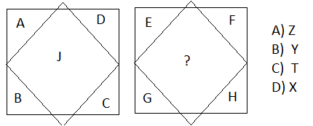
Direction for question No 78 to 80:- In each of the following questions there is a series with on term missing as shown by (?). This term is given as one of the alternatives. Find the correct alternatives:
78. A C F J ? U
A) O B) M C) N D) P
79. 1 5 8 10 11 ?
A) 3 B) 14 C) 11 D) 12
80. MN QRS WXYZ EFGHI ?
A) OPQRS B) MNOPS C) STUVW D) WXYZA
81. In certain code SOCIAL is written as LAICOS how is CHEMISTRY written in that code?
A) STRYCHEM B) YRTSIMEHC C) MECHSTRY D) YRTSCHEM

82. Which answer figure will complete the question figure?
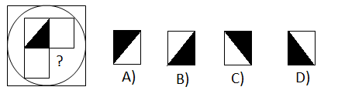
Direction for question No 78 to 80:Out of the given figure three are similar in certain way, one figure is different from others. Which one of the figure does not belong this group?
83.
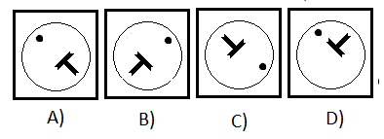
84.
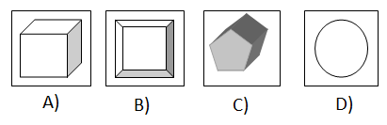
85.
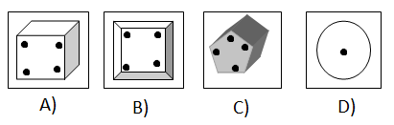

Direction for question No 86 to 89:- Study the following table and answer the following questions:
Current Population of India 2012
Rank | State or union territory | Population (2011 Census) | Density (per km²) | Sex ratio
5 | Andhra Pradesh | 84,665,533 | 308 | 992
26 | Arunachal Pradesh | 1,382,611 | 17 | 920
14 | Assam | 31,169,272 | 397 | 954
3 | Bihar | 103,804,637 | 1102 | 916
17 | Chhattisgarh | 25,540,196 | 189 | 991
25 | Goa | 1,457,723 | 394 | 968
10 | Gujarat | 60,383,628 | 308 | 918
16 | Haryana | 25,353,081 | 573 | 877
20 | Himachal Pradesh | 6,856,509 | 123 | 974
18 | Jammu and Kashmir | 12,548,926 | 56 | 883
13 | Jharkhand | 32,966,238 | 414 | 947
9 | Karnataka | 61,130,704 | 319 | 968
12 | Kerala | 33,387,677 | 859 | 1,084
6 | Madhya Pradesh | 72,597,565 | 236 | 930
2 | Maharashtra | 112,372,972 | 365 | 946
23 | Manipur | 2,721,756 | 122 | 987
22 | Meghalaya | 2,964,007 | 132 | 986
27 | Mizoram | 1,091,014 | 52 | 975
24 | Nagaland | 1,980,602 | 119 | 931
11 | Odisha | 41,947,358 | 269 | 978
15 | Punjab | 27,704,236 | 550 | 893
8 | Rajasthan | 68,621,012 | 201 | 926
28 | Sikkim | 607,688 | 86 | 889
7 | Tamil Nadu | 72,138,958 | 555 | 995
21 | Tripura | 3,671,032 | 350 | 961
1 | Uttar Pradesh | 199,581,477 | 828 | 908
19 | Uttarakhand | 10,116,752 | 189 | 963
4 | West Bengal | 91,347,736 | 1029 | 947

86. Which state of India has highest Sex Ratio?
A) Kerala B) Andhra Pradesh C) Chhattisgarh D) Bihar
87. How many Indian states are having density of population less than 100?
A) 3 B) 4 C) 5 D) 6
88. How many Indian states are having population more than ten crore?
A) 1 B) 2 C) 3 D) 4

89. Which is the second highest populated state in India?
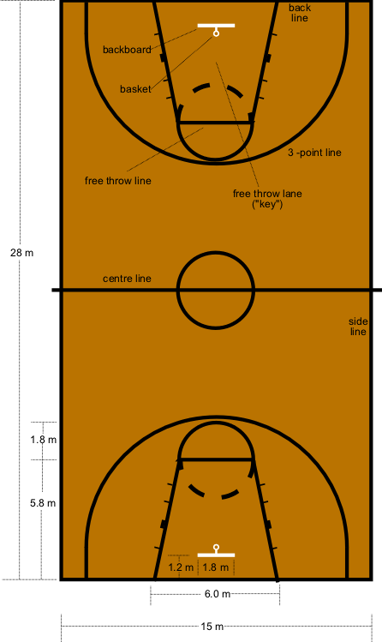
A) Uttar Pradesh B) Gujarat C) Maharashtra D) Bihar
90. Identify the game associated with the following ground:
A) Basket ball
B) Volley Ball
C) Kabadi
D) foot Ball

Space for Rough Works

